1.1P: Preparing for OOP – Answer Sheet

1. Explain the following terminal instructions:
   1. cd: ‘change directory’ – changes the current directory you are working from
   2. ls: ‘list fies’ – this will list all the current files in the current directory.
   3. pwd: ‘print working directory’ – print name of current directory
2. Consider the following kinds of information, and suggest the most appropriate data type to store or represent each:

| Information | Suggested Data Type |
| --- | --- |
| A person’s name | String |
| A person’s age in years | Int |
| A phone number | String |
| A temperature in Celsius | Float |
| The average age of a group of people | Float |
| Whether a person has eaten lunch | Bool |

1. Aside from the examples already given, come up with an example of information that could be stored as:

| Data type | Suggested Information |
| --- | --- |
| String | A street name |
| Integer | Street number |
| Float | Someone’s exact height |
| Boolean | Is a playing card upside down |

1. Fill out the following table, evaluating the value of each expression and identifying the data type the value is most likely to be:

| Expression | Given | Value | Data Type |
| --- | --- | --- | --- |
| 5 |  | 5 | Int |
| True |  |  | bool |
| a | a = 2.5 | 2.5 | Float |
| 1 + 2 * 3 |  | 7 | Int |
| a and False | a = True | False | Bool |
| a or False | a = True | True | Bool |
| a + b | a = 1  b = 2 | 3 | Int |
| 2 * a | a = 3 | 6 | Int |
| a * 2 + b | a = 1.5 b = 2 | 5 | Float |
| a + 2 * b | a = 1.5  b = 2 | 5.5 | Float |
| (a + b) * c | a = 1  b = 1  c = 5 | 10 | Int |
| “Fred” + “ Smith” |  | Fred smith | String |
| a + “ Smith” | a = “Wilma” | Wilma smith | String |

1. Explain the difference between **declaring** and **initialising** a variable.

The difference between the two is that declaring means creating or stating there is a variable where as initialising it means to give that variable a value.

1. Explain the term **parameter**. Write some code that demonstrates a simple of use of a parameter.

A parameter is a special variable that is passed between functions or procedures

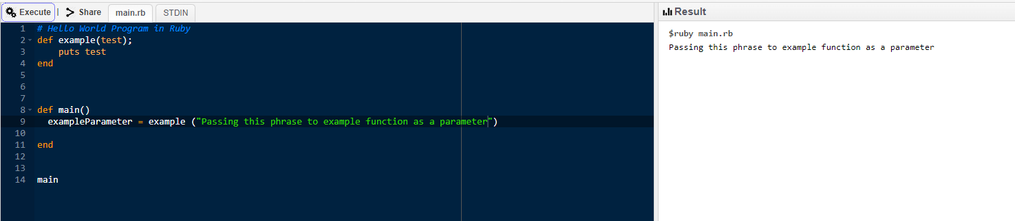

1. Using an example, describe the term **scope**.

Scope is the visibility that the variable has in a program. This can be global (defined outside of a function group) or local (defined within)

1. In any procedural language you like, write a function called Average, which accepts an array of integers and returns the average of those integers.

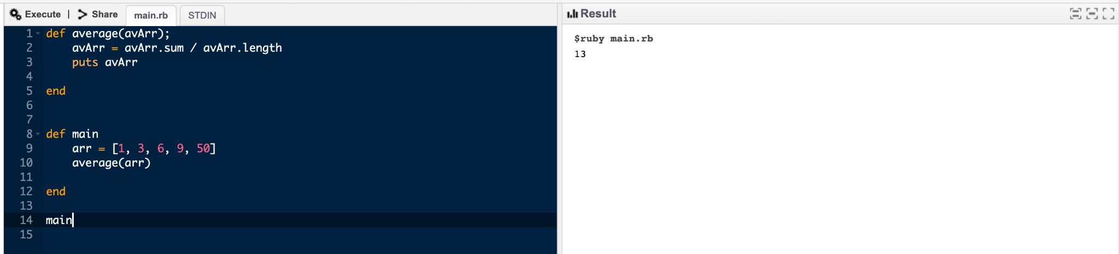

1. In the same language, write the code you would need to call that function and print out the result.



1. To the code from 9, add code to print the message “Double digits” if the average is above 10. Otherwise, print the message “Single digits”.

